The new level 1-f data are now on the server at Z:\soc\l1f\2023\11 and the level 1-r data are at Z:\soc\l1r\2023\11.

I’ve moved the old files into ‘Old’ folders in both directories to keep things organized.

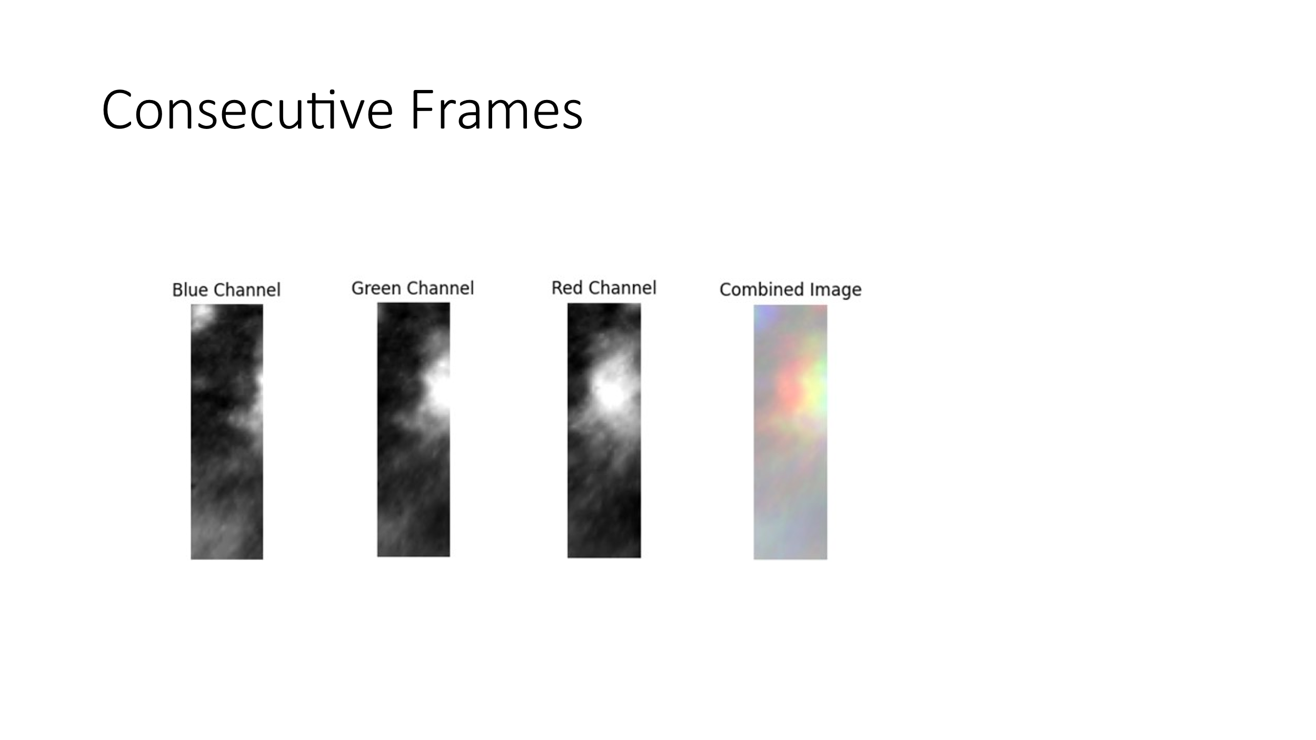

Try Expanding the size of the box, varying the distance of the consecutive frames.

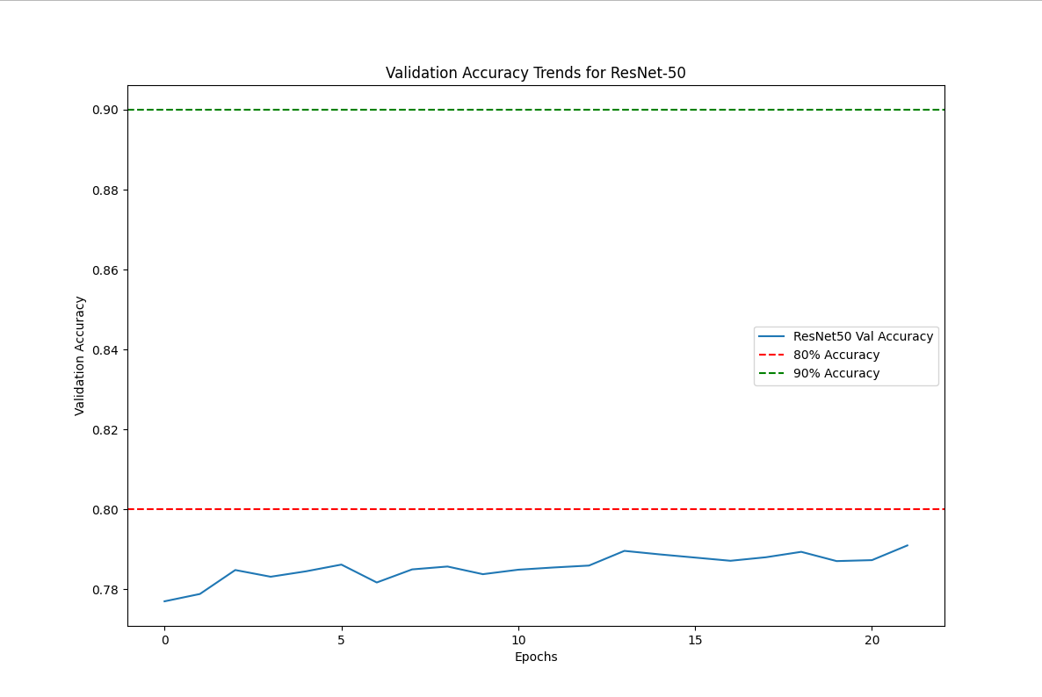

Next:

* Find the best combination of frame difference and box size.
* We will look at the labeled data (the csv file) to make sure the labelling is as consistent as possible.
* Train the model and apply the model to the newly generated files.